1. “The Empath”
A fictional character who was so sensitive to others’ feelings that she could actually take away others’ pains, injuries, etc. and they would become her own. No one on our team has this type of superpower. But all females have the power to feel others’ pain. It’s one of their most precious qualities.
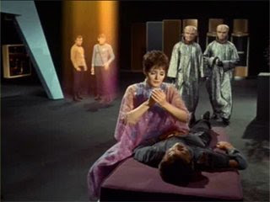 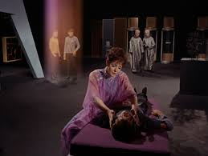

2. So, since you know girls have a little of this power, you need a Shield Against Negativity: from now on referred to as an SAN.
For the rest of this season, we will all deploy our SANs. We will write on our hand, on our water bottles, etc.
For the rest of this season, the Shield with be with us. Everywhere. Always.
Pretty cool animation……..the pic on the left can be seen at: http://fc06.deviantart.net/fs71/f/2014/004/e/6/mystic_ki_forcefield_concept__animated__by_wickedredgrin-d70vwes.gif

3. Coach Houser when he was your age.
This is the best picture I could find of me today. I think here I’m about 11. Not sure.
* Baseball, basketball.
* 8th grade football.
* 9th grade I weighed _____.
I was already done with athletics when I was your age. And it hurt. I cried. A lot. In fact, in order to save my self-esteem I had to convert to being a nerd so that I could be successful at something.
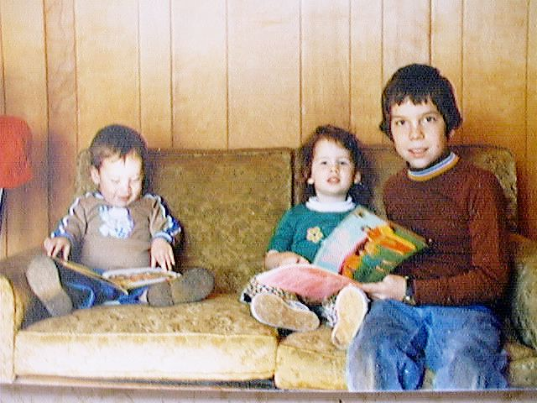 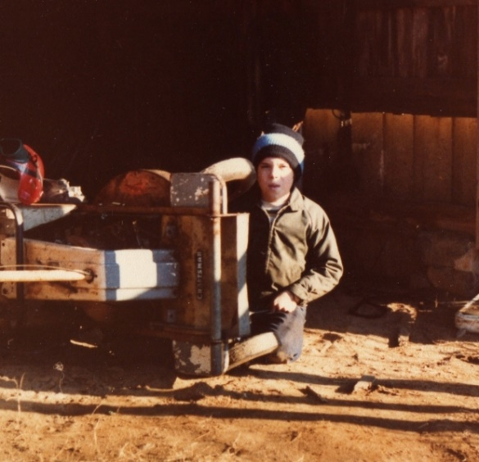

4. Where Our Team Is At Now, and How Good ARE You?
* We all chose this team. We all knew we had 12 very good players.
* We had other nice offers! (If not, then we surely could have!)
* All coaches choose starters. It’s what’s done. Should I just have a bump-and-giggle equal-playing-time team?
* All of you would probably be…………….(can’t type this)
* Think back to Monument: If you were on the team what won 15’s open, would you start? If you were on the team that finished last, would you start? What does that teach you?
* If you stay healthy, keep your grades up, etc. I think there’s a 99% chance that all 12 will be starting on your school’s varsity team someday.
* No one can say, “How does he know……..,” when we’ve had 4 scrimmages, 16 practices, and 7 voluntaries. So we’ve had about 60 hours for everyone to show what they can do. Tonight is 2 more hours of opportunity.
5. We will be better at our SAN. We must be. It will happen.

6. Ok, time to read email. And then hear your comments.

7. Now, after you’re heard everything, write 2 comments that you’d like to share with your team.
Comment # 1:

Comment #2:

